Using Cryptography and Cloud Computing
in the Cyber Security Space for the Transaction of Sensitive Data such as Passwords More Efficiently

Project Synopsis
OF MAJOR PROJECT - PHASE 1

BACHELOR OF TECHNOLOGY
Computer Science and Engineering

SUBMITTED BY
HARSH CHANDRAKAR (309302220027)
J KIRTI RAO (309302220040)
VARUN MAHARANA (309302220094)
SIMRAN DEY BISWAS (309302220098)
AUGUST 2023



BHILAI INSTITUTE OF TECHNOLOGY, RAIPUR
DEPARTMENT OF COMPUTER SCIENCE AND ENGINEERING
TABLE OF CONTENT

Content | Page no.
Introduction | 2
Literature Review | 3
Research Gap | 3
Rationale and Feasibility Study | 4
Project Objectives | 4
Methodology | 5
Dataset Details | 6
Software/Hardware Requirements | 6
Expected Outcomes | 6
References | 7

PROPOSED TOPIC
Using Cryptography and Cloud Computing in the Cyber Security Space for the Transaction of Sensitive Data such as Passwords More Efficiently.

INTRODUCTION
1.1 What is Cryptography?

Cryptography is the practice and study of secure communication techniques, encompassing encryption and decryption methods. It involves converting information into a concealed form to safeguard its confidentiality and integrity during transmission and storage. This field employs mathematical algorithms to create codes that can only be deciphered by intended recipients possessing the appropriate decryption key, ensuring unauthorised access is thwarted.

1.2 What is Cloud Computing?

Cloud computing refers to the delivery of diverse services like storage, processing power, and applications over the internet. It offers on-demand access to these resources, replacing the need for local infrastructure and upfront investments. Users can scale resources as needed, paying for what they use. This model enhances flexibility, efficiency, and cost-effectiveness compared to traditional on-site computing.

1.3 How algorithms in cryptography can be used for the transaction of sensitive data in the cloud?

Numerous cryptographic algorithms like DES, 3DES, Blowfish, AES, RSA, ElGamal, and Paillier are utilised to secure data. Each of these methods possesses distinct characteristics. The challenge lies in determining the most optimal security algorithm that ensures high security while minimising time for key generation, encryption, and decryption. Selection of security algorithms hinges on evaluating their merits, drawbacks, and alignment with specific application needs. Encryption for the cloud computing world is an important issue that needs to be investigated in several studies. One major focus of encryption in cloud computing is identification based on encryption.

LITERATURE REVIEW
We have reviews a number of research papers related to “Using Cryptography and Cloud Computing in the Cyber Security Space for the Transaction of Sensitive Data such as Passwords More Efficiently” and the review is presented as follows:
Sr. no. | Paper Title | Year of publication | Publisher | Author | Category of Paper-Survey or Empirical | Central Theme | Keywords | Approach | Conclusions
1 | Use of Cryptography in Malware Obfuscation | 2023 | IEEE | Aws Naser Jaber, Mohamad Fadli Bin Zolkipli | Implementation | This paper proposes a principled definition of malware obfuscation, and then categorises instances of malware obfuscation that use cryptographic tools into those which evade detection and those which are detectable. | Cryptography, Obfuscation, Malware attacks, decryption algorithm | It has performed simulations in a sample context in which multiple cryptography algorithms have been compared.The visualised results depicts which algorithm is most suitable while achieving a particular quality attribute. | The paper has e shown some results on the real-world use of cryptographic obfuscation by malware programs, this needs to be further validated and refined into different classes of techniques for obfuscation.
2 | A Review on Cryptography in Cloud Computing. | 2020 | IEEE | Ali A.Yassin, Hai Jin, Ayad Ibrahim, Weizhong Qiang, Deqing Zou | Empirical | This paper proposes the phenomenal context according to three main components: data owner, users, and service provider in the cloud where users do not need to register their passwords in the service provider. | Cloud authentication; zero-knowledge proof; service provider; password authentication; privacy-preserving | This paper presents an approach for password authentication. It carries out a sample of the plotted scheme, which exhibited good performance and accuracy. The proposal method assumes a configuration where users keep their passwords far away from service providers in the cloud. These features have gained a good chance for service providers to increase time processing. | To provide solutions to these problems, it proposed a password-preserving for data-storage security in cloud computing, which alleviates the users scared of their data leakage. The proposed algorithm provides a balanced solution between the security and performance.

- RESEARCH GAP
The research gaps from the reviewed research papers that were observed are as follows:
- In the above reviewed paper, one major gap which could be researched was the total types present in the Symmetric and Asymmetric algorithms.
- One of the prominent cryptographic techniques which have been researched to provide privacy and fine-grained access control in cloud computing is Attribute Based Encryption.
- The paper has explored more on ciphertext policy attribute based encryption in different aspects such as hidden policy, proxy re-encryption, revocation mechanism, and hierarchical attribute based encryption.
- The paper has analysed the top security threats and their existing solutions and also investigates the challenges/obstacles in implementing threat remediation.

- RATIONALE AND FEASIBILITY STUDY

Sensitive data such as passwords play a major role in keeping data and information safeguard. It verifies identity, avoids document manipulation, and builds trust between servers as the cornerstone of modern security systems. Cryptography is among the most effective techniques organisations use to safeguard their storage systems, whether at rest or in transit.
The foundation of contemporary security systems is identity verification, which prevents document manipulation and fosters server trust.
One of the best methods used by businesses to protect their storage systems, whether at rest or in transit, is cryptography.The only way to protect data while it is being delivered and stored is by encrypting it. Without the proper decryption keys, the encrypted data is essentially worthless to unauthorised persons even if the transferor storage media is compromised. Cryptography employs message digests and hash function algorithms to preserve data integrity. By providing codes and digital keys to verify that what is received is genuine and from the authorised sender, the receiver is assured that the data they have obtained has not been tampered with during communication.

- PROJECT OBJECTIVES
The objectives that are aimed to be fulfilled by the project are as follows:
- The confidentiality of the information is preserved. Confidentiality is required to safeguard the privacy of those whose private information is kept. Privacy is cloud cryptography's key benefit. Users' data remains protected because the specifics will be kept secret, and the possibility of fraud by unauthorised users is diminished.
- Ensuring the integrity of data. Integrity in the security environment refers to the accuracy of information management and associated information. When a system is ‘integrated,’ it indicates that the data is transported and handled in controlled situations. The data remains unchanged even after it has been processed.
- Assuring the right sender or receiver. The accuracy of the information's origin or destination, as well as the identities of the transmitter and receiver, is ensured by this project. Only a specific key exchange used by the sender to confirm their identity can ensure authenticity
- METHODOLOGY/PLANNING OF WORK

The approach or planning for the project is to study the various types of encryption algorithms in cryptography and to also study the available methods to store data in the cloud storage securely and to combine both the means and methods and try to store only the encrypted data in the cloud.

The types of encryption algorithms mainly include:
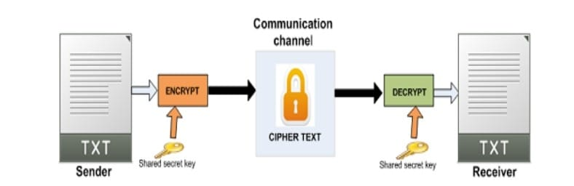
- Symmetric Key Cryptographic Algorithm- This algorithm gives authentication and authorization to the data because data encrypted with a single unique key cannot be decrypted with any other key. Data Encryption Standard (DES), Triple Data Encryption Standard (3DES), Advanced Encryption Standard (AES) are the most popular 2.Symmetric-key Algorithms which are used in cloud computing for cryptography.

- Asymmetric Key Cryptographic Algorithm- This algorithm is using two separate different keys for the encryption and decryption process in order to protect the data on the cloud. The algorithms used for cloud computing are Digital Signature Algorithm (DSA), RSA and Diffie-Hellman Algorithm.
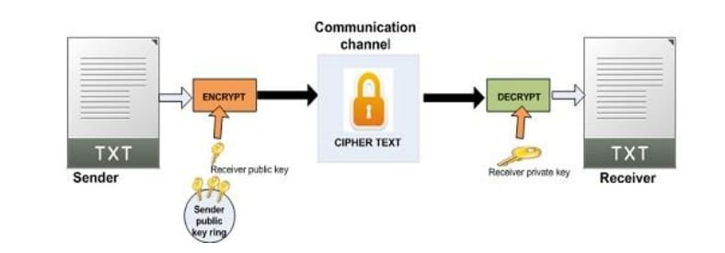

- Hashing- It is mainly used for indexing and recovering items in a database. It also utilises two separate keys for encrypting and decrypting a message

7. DATASET DETAILS

There is no dataset in this project.

8. SOFTWARE/HARDWARE REQUIREMENTS FOR THE DEVELOPMENT OF PROJECT
8.1 Software Requirements
A robust development environment such as Eclipse IDE, a modern web browser such as Google Chrome, a cloud service provider such as Amazon Web Services and some additional supporting software packages.

8.2 Hardware Requirements
An Intel i-series 2.5Ghz processor with 4 GB RAM and 512 GB of available storage.

9. EXPECTED OUTCOMES
The expected outcome that are aimed to be fulfilled by the project are as follows:
- The confidentiality of the information is preserved. Users' data remains protected because the specifics will be kept secret, and the possibility of fraud by unauthorised users is diminished.
- Ensuring the integrity of data. Integrity in the security environment refers to the accuracy of information management and associated information. The data remains unchanged even after it has been processed.
- Assuring the right sender or receiver. The accuracy of the information's origin or destination, as well as the identities of the transmitter and receiver, is ensured by this project. Only a specific key exchange used by the sender to confirm their identity can ensure authenticity.

10. REFERENCES
[1] Muller, M. A., Grundy, I., & Morsy, J. (2014). An analysis of the cloud computing security problem. Int. Surg, 47(3), 288-290.
[2] Abdulsalam, Y.S.A.; Hedabou, M. Security and Privacy in Cloud Computing: Technical Review. Future Internet 2022, 14, 11. https:// doi.org/10.3390/fi14010011
[3] Olowu, M., Yinka-Banjo, C., Misra, S., & Florez, H. (2019). A Secured Private-Cloud Computing System. Applied Informatics, 373–384. https://doi.org/10.1007/978-3-030-32475-9_27
[4] Jackson, K. R., Ramakrishnan, L., Muriki, K., Canon, S., Cholia, S., Shalf, J., ... & Wright, N. J. (2010, November). Performance analysis of high performance computing applications on the amazon web services cloud. In 2010 IEEE second international conference on cloud computing technology and science (pp. 159-168). IEEE.
[5] Khan, A. R., & Alnwihel, L. K. (2023). A Brief Review on Cloud Computing Authentication Frameworks. Engineering, Technology & Applied Science Research, 13(1), 9997-10004.
[6] Verma, O. P., Agarwal, R., Dafouti, D., & Tyagi, S. (2011, April). Notice of Violation of IEEE Publication Principles: Performance analysis of data encryption algorithms. In 2011 3rd International Conference on Electronics Computer Technology (Vol. 5, pp. 399-403). IEEE.
[7] Asghar, H. J., Zhao, B. Z. H., Ikram, M., Nguyen, G., Kaafar, D., Lamont, S., & Coscia, D. (2022). SoK: Use of Cryptography in Malware Obfuscation. arXiv preprint arXiv:2212.04008.

